| **Council Officers** | |  | **Council Members** | |
| --- | --- | --- | --- | --- |
| **President** | Stephen Stowe | Wenming (Angie) Chen |  |
| **First Vice President** | John Ricottone | Yanqing (Angi) Chen  Alina Lewis | Sabrina McNamara (D75 Rep)  Fabiola Mendieta-Cuapio (BP Rep)  Maya Rozenblat (ELL Rep) |
| **Second Vice President** | Elizabeth Chan (IEP Rep) | Ryan Li (Student Rep) | Tamara Stern (BP Rep) |
| **Recording Secretary** | Kevin Zhao |  |  |
| **Treasurer** | Meifang (Junmi) Chen |  |  |



Resolution 3 (SY24-25)

**Resolution to Fix the Safety Transfer Process and Address Increase in Bullying, Harassment and Discrimination in NYC Public Schools**

**Approved by a vote of ____ on _______**

**1.** **Stephen Stowe -**

**2.** **John Ricottone -**

**3.** **Elizabeth Chan -**

**4.** **Kevin Zhao -**

**5. Meifang (Junmi) Chen -**

**6.** **Wenming (Angie) Chen -**

**7. Yanqing (Angi) Chen**

**8. Alina Lewis -**

**9. Sabrina McNamara -**

**10.** **Fabiola Mendieta-Cuapio -**

**11.** **Maya Rozenblat -**

**12.** **Tamara Stern -**

**Sponsors: John Ricottone**

**Co-sponsors: Elizabeth Chan, Meifang Chen, Stephen Stowe, Kevin Zhao,Yanqing (Angi) Chen, Alina Lewis**

**WHEREAS**, A school is a safe haven for all students. At no time should a child’s safety be jeopardized, whether it’s from being bullied, harassed, or assaulted. The safety of each child inside and outside of their public school is paramount.

**WHEREAS**, incidents of bullying, harassment and discrimination are increasing dramatically in the New York City Public Schools. From School Year 2017-2018 to School Year 2023-2024, material incidents increased 213%, from 4,907 in SY 2018 to 15,371 in SY 24[1] (Appendix 1). This increase is even more concerning when we consider that the total number of K-8 students in the system has declined 28% over this time period, falling from 734,206 to 528,309[2]. At times, children are afraid to go to school. Bullying, harrassment and discrimination can lead them to become depressed or even suicidal[3].

**WHEREAS,** per the 2024-2025 District Comprehensive Education Plan (DCEP), District 20 has a goal of ensuring all students are physically and emotionally safe. Overall, the rate of bullying and harassment has remained consistent since 2018. And in calendar year 2024, only 5 bullying incidents The District has acknowledged a recent increase in bullying at 5 schools (220, 030, 259, 180, 223) and has set a goal of reducing Level 4 and 5 incidents at these schools by the end of the school year.

**WHEREAS,** New York City Public Schools (NYCPS) have numerous ways to report bullying incidents.

•online complaint www.nycenet.edu/bullying reporting.

•Contact the Office of Safety and Youth Development (OSYD) by calling (718) 935-2288 or 311.

• You can also utilize the 311 application via phone or computer.

•Send an email to [RespectforAll@schools.nyc.gov](mailto:RespectforAll@schools.nyc.gov)

•Parents/Guardians/Students can contact staff at the school including teachers, counselors and principals

**WHEREAS,** Chancellor Regulation A-450 is an involuntary transfer when a student(s) behavior and/or academic record demonstrate that adjustment in school is unsatisfactory and if the principal believes the student would benefit from a transfer or receive an appropriate education at another school.

**WHEREAS,** Chancellor Regulation A-449 is a regulation that grants safety transfers when students are victims of violent criminal offenses on school property and when other situations arise, it is determined that a student's presence in the school is unsafe for the student.

**WHEREAS**, According to the National Center for Educational Statistics, 41% of students who reported being bullied at school, indicated that they think the bullying would happen again[4].

**WHEREAS**, a multi-national meta-analysis found that school-based bullying prevention programs decrease bullying by 20-23% and victimization by 17-20%[5].

**WHEREAS**, New York City Public Schools (NYCPS) anti-bullying policies are codified in Chancellor’s Regulations including Regulations A-832 and A-443. The abstract from A-832 is quoted below:

“It is the policy of the New York City Department of Education (“DOE”) to maintain a safe and supportive learning and educational environment that is free from harassment, intimidation and/or bullying committed by students against other students and discrimination by students against other students on account of actual or perceived race, color, creed, ethnicity, national origin, citizenship/immigration status, religion, gender, gender identity, gender expression, sexual orientation, disability, or weight. Such discrimination, harassment, intimidation and/or bullying is prohibited and will not be tolerated in school, during school hours, during online learning, before or after school, while on school property, at school sponsored events, while traveling in vehicles funded by the DOE or off school property when such behavior disrupts or would foreseeably disrupt the educational process or endangers or would foreseeably endanger the health, safety, morals, or welfare of the school community. This regulation sets forth reporting, investigative, notification, and follow-up procedures for student-to-student discrimination, harassment, intimidation and/or bullying. Students who have engaged in behavior which violates this regulation will receive interventions, supports, and disciplinary responses, as appropriate, consistent with the Citywide Behavioral Expectations to Support Student Learning (“Discipline Code”) and Chancellor’s Regulation A-443. **Victims and witnesses will receive interventions and supports as appropriate.** For complaints of peer sexual harassment, please refer to Chancellor’s Regulation A-831”.[6]

The abstract from A-443 is quoted below:

“This Regulation governs the intervention and discipline procedures for all students. It supersedes Chancellor’s Regulation A-443 issued July 1, 2001. The Chancellor may change this Regulation consistent with applicable federal and state laws without further public hearings. Procedures governing the involuntary transfer of students in general education (those without an IEP) are provided separately in Chancellor’s Regulation A-450, Involuntary Transfer Procedures”[7].

**WHEREAS**, perpetrators of bullying must be held accountable for their actions. Serious physical injury on a victim should prevent the perpetrator from returning to the school. Firm guidelines need to be outlined regarding suspensions and transfers , taking into consideration the degree and frequency of assaults. The Discipline code with the New York City Public Schools (NYSPS) is divided by two different groups by grade. The first group for grades K-5 and the second group being grades 6-12. The Discipline Code is set forth on the NYCPS website for both [grades K-5](https://cdn-blob-prd.azureedge.net/prd-pws/docs/default-source/default-document-library/discipline-code-kindergarten-grade-5.pdf?sfvrsn=2e632999_8) and [grades 6-12](https://cdn-blob-prd.azureedge.net/prd-pws/docs/default-source/default-document-library/discipline-code-grades-6-12.pdf?sfvrsn=c9d6a6f3_8).

**WHEREAS**, in many situations NYCPS allows the victim to receive a safety transfer. However it is currently much more difficult to arrange a safety transfer for a perpetrator. Therefore, in many cases the victim is the student who ends up having to disrupt their education with a transfer to another class room or school.

**THEREFORE, be it resolved, the Community Education Council for District 20 asks the Panel for Education Policy, Chancellor Melissa Aviles-Ramos, and Chief of Safety & Prevention Partnerships Mark Rampersant to implement the following policies:**

* In situations where a safety transfer under A-449 is being considered for a victim, the NYCPS first must consider an involuntary transfer under A-450 for the perpetrator. In cases where a safety transfer is the only solution, the perpetrator must be transferred before the victim. Likewise, in cases where the perpetrator committed a Level 4 or 5 offense, a transfer must be made.
  + Amend the Introduction of A-450 to read as follows (amended text shown in bold): “This regulation describes the procedures for effectuating the involuntary transfer of students in general education (those without IEPs) pursuant to Section 3214(5) of the New York State Education Law. When possible, alternative interventions should be utilized before initiating involuntary transfer proceedings. When a student’s behavior and/or academic record demonstrate that adjustment in school is unsatisfactory and if the principal believes that the student would benefit from a transfer or receive an appropriate education elsewhere, the principal may pursue an involuntary transfer in accordance with this regulation. Every effort should be made to minimize any disruption to the student’s education. **However, notwithstanding the above, in situations of demonstrated bullying, harassment or assault, which lead to consideration of a Safety Transfer for the victim pursuant to Chancellor’s Regulation A-449, the school should always first consider an involuntary transfer pursuant to Chancellor’s Regulation A-450 for the perpetrator.”**
* Review all existing disciplinary policies and based on quantitative and qualitative data determine what policies are most effective at reducing bullying, harassment, and discrimination. Review ineffective policies and make changes, recognizing that there is no one-size-fits-all policy for different schools and Districts.
* Be it further resolved, NYCPS prioritizes supporting schools with the highest rates of Material Incidents reported under Local Law 51 to provide the resources they need to keep students safe.
* Be it further resolved, that a follow-up program survey is taken of students at the end of each school year in order to verify that they have retained the content knowledge from the annual, mandated anti-bullying training.

[8]<https://cdn-blob-prd.azureedge.net/prd-pws/docs/default-source/default-document-library/a-450-involuntary-transfer-procedures-english.pdf?sfvrsn=1bcf1d89_48>

[9]<https://www.schools.nyc.gov/docs/default-source/default-document-library/discipline-code-kindergarten-grade-5-english.pdf>

**Appendix 1 - Material Incidents of Bullying, Harassment and Discrimination reported under Local Law 51 (School Year 2018 - School Year 2024)**

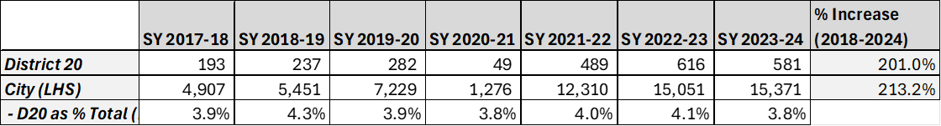

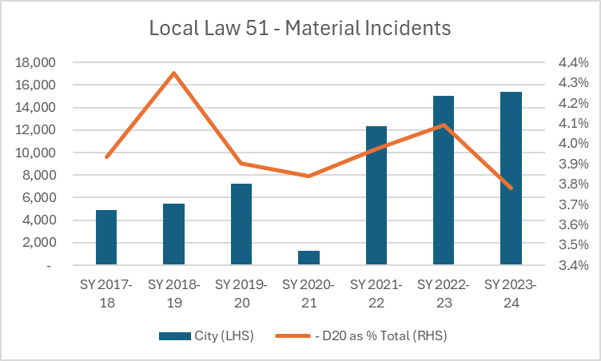

1. [Bullying, Harassment and Discrimination](https://infohub.nyced.org/reports/government-reports/bullying-harassment-and-discrimination)
2. [Information and Data Overview](https://infohub.nyced.org/reports/students-and-schools/school-quality/information-and-data-overview)
3. [An Observational Study of Bullying as a Contributing Factor in Youth Suicide in Toronto - PMC](https://pmc.ncbi.nlm.nih.gov/articles/PMC4304582/)
4. [Student Reports of Bullying Results From the 2017 School Crime Supplement to the National Crime Victimization Survey (ed.gov)](https://nces.ed.gov/pubs2019/2019054.pdf)
5. D.P. Farrington and M.M. Ttofi, School-based programs to reduce bullying and victimization, Campbell Systematic Reviews No. 6 (2009)
6. [A-832 10-7-2021 Final Posted (nyc.gov)](https://www.schools.nyc.gov/docs/default-source/default-document-library/a-832-student-to-student-discrimination-harassment-intimidation-and-or-bullying.pdf)
7. [A-443 student disciplene procedures (nyc.gov)](https://www.schools.nyc.gov/docs/default-source/default-document-library/a-443-3-5-04-english.pdf)