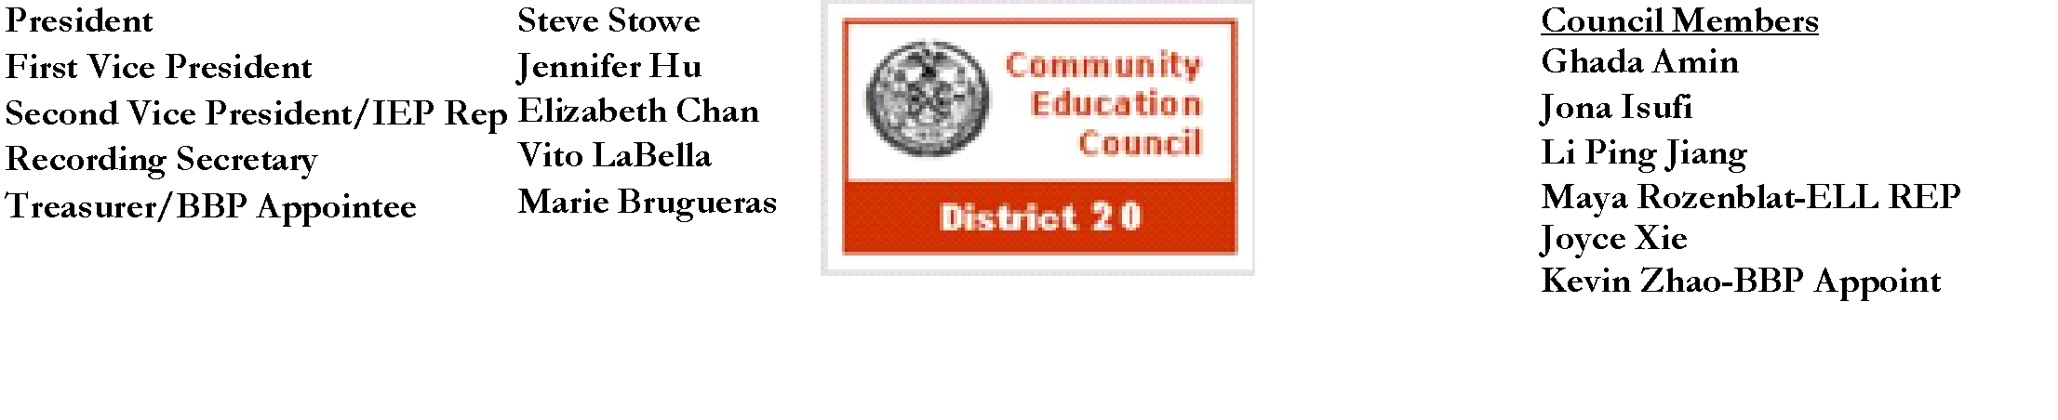

**Community Education Council District 20**

**August Business Meeting**

**Date:** Wednesday, August 14th, 2024

**Meeting Start Time:** 7:51 PM

**Present:** Steve Stowe, Joyce Xie, Yanqing Chen, Meifang Chen, Tamara Stern, Kevin Zhao, Wenming Chen, John Ricottone, Fabiola Mendieta-Cuapio, Sabrina Mcnamara, Elizabeth Chan

**Excused**:

**Unexcused:** Maya Rozenblat

**I. Meeting Called to Order:** John Ricottone, First Vice President

**a. Roll Call:** Joyce Xie, Recording Secretary

**II. Old Business** - Approval of the July 2024 Business Meeting Minutes

Minutes Approved unanimously

**III. New Business**

**a.** CEC 20 discussed and approved the budget for FY 2024-2025

Steven Stowe - Yes

John Ricottone - Yes

Elizabeth Chan - Yes

Joyce Xie - Yes

Meifang Chen - Yes

Tamara Stern - Yes

Wenming Chen - Yes

Yangqing Chen - Yes

Kevin Zhao - Yes

Maya Rozenblat - Absent

Fabiola Mendieta-Cuapio - Yes

Sabrina Mcnamara - Yes

**III. Adjourn**

a.Motion to adjourn - Joyce Xie, Second: Wenming Chen

**i.** All in favor

b**.** Meeting adjourned at 8:57 PM

The full meeting recording is available here: [YouTube](https://youtu.be/oLGy6PekTS0?si=3ZcRiPRGsww4VxFf)

The Complete written Transcript is available here: [Transcript](https://www.cec20.org/minutes)

Submitted by Kevin Vizhnay, Administrative Assistant