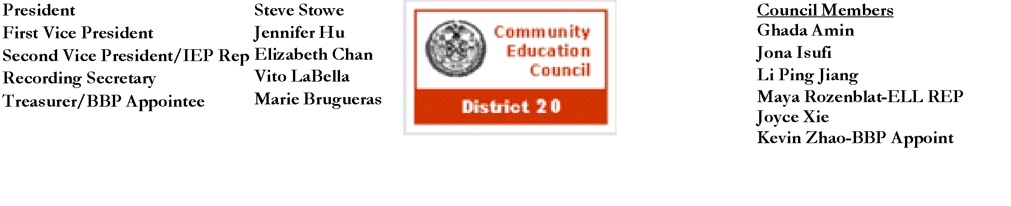

**Community Education Council District 20**

**October Business Meeting**

**Date:** Wednesday, October 9th, 2024

**Meeting Start Time:** 8:26 PM

**Present:** Steve Stowe, Joyce Xie, Yanqing Chen, Meifang Chen, Tamara Stern, Wenming Chen, John Ricottone, Fabiola Mendieta-Cuapio, Sabrina Mcnamara, Elizabeth Chan, Maya Rozenblat,

**Excused**: Kevin Zhao

**Unexcused:** Ryan Li

**I. Meeting Called to Order:** Stephen Stowe, President

**a. Roll Call:** Stephen Stowe, President

**II. Old Business** - Approval of the September 2024 Business Meeting Minutes

Minutes Approved unanimously

**III. New Business**

1. The council went over budgeting procedures for Welcome Back Breakfast Event (10/25)

**III. Adjourn**

a.Motion to adjourn -Elizabeth Chan, Second: Wenming Chen

**i.** All in favor

b**.** Meeting adjourned at 8:55 PM

The full meeting recording is available here: [YouTube](https://youtu.be/T0u9rTIy8zg?si=zP9TUamhNmsedNaw)

The Complete written Transcript is available here: [Transcript](https://www.cec20.org/minutes)

Submitted by Kevin Vizhnay, Administrative Assistant