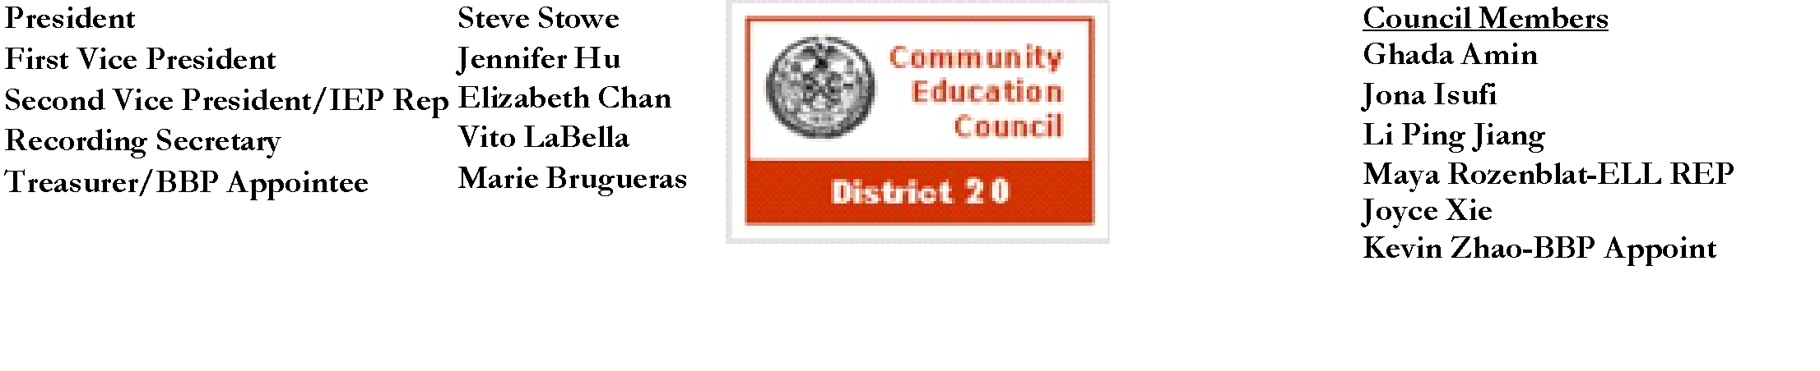

**Community Education Council District 20**

**November Business Meeting**

**Date:** Wednesday, November 13th, 2024

**Meeting Start Time:** 9:01 PM

**Present:** Steve Stowe, Yanqing Chen, Meifang Chen, Tamara Stern, Wenming Chen, John Ricottone, Fabiola Mendieta-Cuapio, Sabrina Mcnamara, Elizabeth Chan, Maya Rozenblat, Kevin Zhao

**Excused**:

**Unexcused:** Ryan Li

**I. Meeting Called to Order:** Stephen Stowe, President

**a. Roll Call:** Stephen Stowe, President

**II. Old Business** - Approval of the October 2024 Business Meeting Minutes

Minutes Approved unanimously

**III. New Business**

1. Motion to vote on the adjustment of the budget and move funds accordingly - Maya Rozenblat, Second: Wenming Chan

* Move $350 from Equipment and $875 from Reimbursements to Parent Involvement - Events & Imprinted Items

Steven Stowe - Yes

John Ricottone - Yes

Elizabeth Chan - Yes

Meifang Chen - Yes

Tamara Stern - No Vote

Wenming Chen - Yes

Yangqing Chen - Yes

Kevin Zhao - Yes

Maya Rozenblat - Yes

Fabiola Mendieta-Cuapio - Yes

Sabrina Mcnamara - Yes

1. Motion to vote on the use of funds to purchase breakfast food for upcoming event with District 20 - Elizabeth Chan, Second: Maya Rozenblat

Steven Stowe - Yes

John Ricottone - Yes

Elizabeth Chan - Yes

Meifang Chen - Yes

Tamara Stern - No Vote

Wenming Chen - Yes

Yangqing Chen - Yes

Kevin Zhao - Yes

Maya Rozenblat - Yes

Fabiola Mendieta-Cuapio - Yes

Sabrina Mcnamara - Yes

**III. Adjourn**

a.Motion to adjourn - Elizabeth Chan, Second: Wenming Chen

**i.** All in favor

b**.** Meeting adjourned at 9:29 PM

The full meeting recording is available here: [YouTube](https://youtu.be/nyTcd_DfdsE?si=5D5Vltmp0lmHMTao)

The Complete written Transcript is available here: [Transcript](https://www.cec20.org/minutes)

Submitted by Kevin Vizhnay, Administrative Assistant