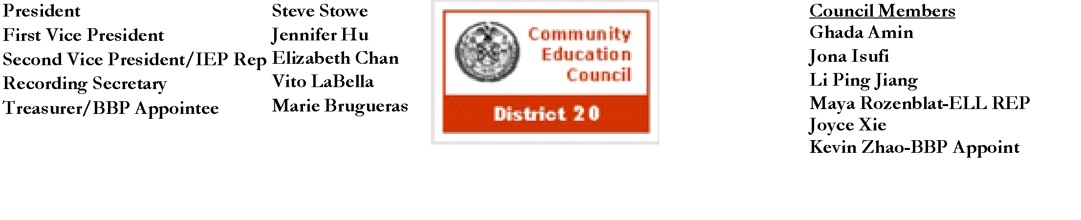

**Community Education Council District 20**

**October Calendar Meeting**

**Date:** Wednesday, October 9th, 2024

**Meeting Start Time:** 6:00 PM

**Present:** Steve Stowe, Joyce Xie, Yanqing Chen, Meifang Chen, Tamara Stern, John Ricottone,Wenming Chen**,** Kevin Zhao, Fabiola Mendieta-Cuapio, Sabrina Mcnamara, Elizabeth Chan, Maya Rozenblat

**Excused**:

**Unexcused**: Ryan Li,

**I. Meeting Called to Order:** Stephen Stowe, First Vice President

**II. Roll Call**:Stephen Stowe, First Vice President

**III. New Business**

1. **Public Speaking Session**

Assemblyman Lester Chang shared upcoming events his office is holding (past). Also spoke about his office's efforts to address after school funding issues. Joyce Xie, representing City Council Susan Zhuang, provided a report of the city council members efforts to help the community. This includes keeping up to date with projects in D20 from the School Construction Authority, upcoming events (past). Frances Brown, representing Senator Iwen Chu, provided an overview of upcoming events (past). Community members spoke on the issues with bussing for D75 students. Some students still do not have access to proper bussing services to get to school. They share concerns that students with bussing services may not be eligible for student OMNY passes which hinders their ability to attend after school programs.

1. **Afterschool Program Discussion with Senior Executive Director of the Office of Community Schools, George Patterson and Chief of Schools for Community Supports and Wellness, Flavia Puello-Perdomo**

Responsible for supporting community school initiatives, supporting attendance intervention, and supporting students in temporary housing and foster care. Centrally, they support over 900 afterschool programs. The vast majority of support for after school comes from their partnerships with the Department of Youth and Community Development (DYCD). A portion of support comes from community schools which work to provide extending learning (after school), and there are grant opportunities ie,. LEAPS. While there are over 900 after school programs across the city, there are over 300 schools with non-centrally supported after school programs (no direct allocation from central to support these programs). In regard to District 20, there are 30 programs supported across the 44 schools. 29 schools are supported through Beacon or Compass and 13 schools are not centrally supported. In regard to the recent changes with Empire (after school programs). After school program providers partake in a competitive application process to obtain state grants. Historically, school districts were able to apply to these grants for schools in partnerships with Community Based Organizations (CBOs). Now, school districts are no longer the applicants, instead the CBOs are. The state's additional $3 million grant will not fully address the issue as it is a multimillion dollar problem. Council members discussed the current allocation of funds, the potential distribution of incoming funds, communication with the Office of Children and Family Services, and future goals and actions.

1. **Superintendent Pretto Report**

With middle school admissions open, Superintendent Pretto invited middle schools to provide introductory presentations. These schools include J.H.S. 62 Ditmas, J.H.S. 223 Montauk, J.H.S. 220 Pershing, M.S. 407 STARS, I.S. 686 Brooklyn School of Inquiry, and M.S. 936 Arts Off Third. Dr. Pretto also announced a new monthly meeting, “[Family Support Mondays](https://sites.google.com/schools.nyc.gov/d20website/home)”, to directly speak with families.

1. **Borough President Appointee, Tamara Stern, Update -**

Applications for funding school initiatives will be open in January through the Borough President's office (Reso A). The Borough President is also starting a Community Baby Shower Funding which provides Brooklyn nonprofits the opportunity to request up to $5,000 in reimbursed funding for non personal expenses.

1. **Voting For New Recording Secretary**

Voting was delayed as CEC 20 did not have enough members in person to meet quorum.

1. **Assignment of Liaison Schools**

The three new schools in District 20 were assigned a CEC member as their liaison. Fabiola Mendiata-Cuapio is the liaison for P.S. 331 The Detective Wenjian Liu School of Civics and Entrepreneurship, Tamara Stern is the liaison for M.S. 407 School of Technology, Arts, and Research, and Stephen Stowe is the liaison for P.S. 413 Joanne Seminara School of Law & Medicine.

**Public Speaking Session**

Community members spoke on the need for afterschool programs. They appreciate the efforts being made by CEC 20 and supporting offices to ensure the continuity of afterschool programs and to seek answers as to why these programs are being hindered.. Members also shared thoughts on Fair Student Funding and math curriculum.

**IV. Old Business** - Approval of the September 2024 Calendar Minutes

Calendar Meeting Minutes Approved

**V. Adjourn**

a. Motion to adjourn - Elizabeth Chan, Second: John Ricottone

I. All in favor

b. Meeting adjourned at 8:25 PM

The full meeting recording is available here: [YouTube](https://youtu.be/3J3-PlxRhCk?si=x7Af8IrOToMQJWZ3)

The Complete written Transcript is available here: [Transcript](https://www.cec20.org/meetingdocuments)

Submitted by Kevin Vizhnay, Administrative Assistant