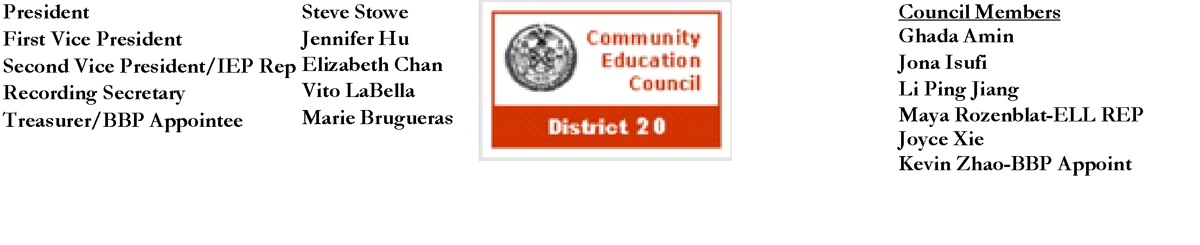

**Community Education Council District 20**

**November Calendar Meeting**

**Date:** Wednesday, November 13th, 2024

**Meeting Start Time:** 6:00 PM

**Present:** Steve Stowe, Yanqing Chen, Meifang Chen, Tamara Stern, John Ricottone,Wenming Chen**,** Kevin Zhao, Fabiola Mendieta-Cuapio, Sabrina Mcnamara, Elizabeth Chan, Maya Rozenblat

**Excused**:

**Unexcused**: Ryan Li,

**I. Meeting Called to Order:** Stephen Stowe, First Vice President

**II. Roll Call**:Stephen Stowe, First Vice President

**III. New Business**

1. **Opening Remarks**

Principal Capetanakis welcomed the community, staff, and CEC 20 to P.S. 69. In celebration of World Kindness Day, Principal Capetanakis presented District 20 staff and CEC 20 members with certificates for their contributions to the community.

1. **Public Speaking Session**

A representative from District 38 Council Member Alexa Aviles office shared information regarding office hours and best means of contact.

1. **High Schools in District 20 Presentation**

In preparation for high school admissions (closed on Dec 9th), all high schools located in District 20 provided an overview of their schools including programs, student life, curriculum, sports, college readiness programs, and application process. These schools include Fort Hamilton High School, Franklin D. Roosevelt High School, High School of Telecommunication Arts and Technology, MESA 2 Charter High School, New Utrecht High School, and Urban Assembly School for Leadership and Empowerment.

1. **Presentation from District 75**

D75 Deputy Superintendent Shelly Klainberg, Administrative Assistant Helen Kaufman, Director of the Office of Related and Contractual Services Angela Torres, Executive Director of Student Support and Operations Mandy Paulson, and Family Support Coordinator Nora Almodovar-eckert provided an overview of their roles and impact on D75 students in NYCPS. In District 20, there are 6 D75 school organizations with 13 sites. Regarding afterschool programs, all D75 schools received funding to provide these programs. Though, due to a lack of available drives, bussing for these students is not available. The council asked several questions regarding staffing issues, providing RSA (Related Services Authorization), the effectiveness of remote learning, and more.

1. **Superintendent Pretto Report**

Superintendent Pretto went over District 20s events and accomplishments. This includes welcoming Chancellor Aviles-Ramos to District 20, winners from the P.S./I.S. 104 Readathon, the success of their new program Family Support Monday, and their upcoming FSM topic, bullying.

1. **Public Speaking Session**

A representative from Brooklyn Borough President's Antonio Reynoso, provided an overview of their Reso A Funding program, which, similar to SCA, provides funding to schools for specific needs. Submissions will open in early January and end in mid February (Final Dates TBD)

1. **Vote on new CEC Member**

The council members will take a roll call vote and announce which candidate they prefer. A new member is elected when they receive 7 votes. Motion to vote on new CEC member - John Ricottone, Second: Elizabeth Chan

Steven Stowe - Alina Lewis

John Ricottone - Alina Lewis

Elizabeth Chan - Alina Lewis

Meifang Chen - Nengying Shi

Tamara Stern - Sarah Cooley-Cordara

Wenming Chen - Alina Lewis

Yangqing Chen - Alina Lewis

Kevin Zhao - Alina Lewis

Maya Rozenblat - Alina Lewis

Fabiola Mendieta-Cuapio - Not Present

Sabrina Mcnamara - Sarah Cooley-Cordara

1. **Vote on Recording Secretary**

Stephen Stowe nominates Kevin Zhao. Motion to vote on new recording secretary - John Ricottone, Second: Maya Rozenblat

Steven Stowe - Kevin Zhao

John Ricottone - Kevin Zhao

Elizabeth Chan - Kevin Zhao

Meifang Chen - Kevin Zhao

Tamara Stern - Abstain

Wenming Chen - Kevin Zhao

Yangqing Chen - Kevin Zhao

Kevin Zhao - Kevin Zhao

Maya Rozenblat - Kevin Zhao

Fabiola Mendieta-Cuapio - Kevin Zhao

Sabrina Mcnamara - Kevin Zhao

1. **Resolution 2 - Urging the Panel for Educational Policy (PEP) to Approve the Contract For The Specialized High School Admission Test (SHSAT)** Motion to Approve Resolution 2 - John Ricottone, Second: Kevin Zhao

Steven Stowe - Yes

John Ricottone - Yes

Elizabeth Chan - Yes

Meifang Chen - Yes

Tamara Stern - No

Wenming Chen - Yes

Yangqing Chen - Yes

Kevin Zhao - Yes

Maya Rozenblat - Yes

Fabiola Mendieta-Cuapio - Yes

Sabrina Mcnamara - Yes

**IV. Old Business** - Approval of the October 2024 Calendar Minutes

Calendar Meeting Minutes Approved

**V. Adjourn**

a. Motion to adjourn - Elizabeth Chan, Second: John Ricottone

I. All in favor

b. Meeting adjourned at 8:55 PM

The full meeting recording is available here: [YouTube](https://youtu.be/fFvoxdAIf8A?si=EidBGgR5col0_uJd)

The Complete written Transcript is available here: [Transcript](https://www.cec20.org/meetingdocuments)

Submitted by Kevin Vizhnay, Administrative Assistant